Assessment Tool 3
CO3_AT2_Case Study

Course: Computer Vision Name: K.Teja Sri
Course Code: ITA0506 Register No: 192525249

1.A remote sensing application is used to align satellite images of the same geographical region captured at different times for monitoring environmental changes. The system initially relies on edge detection to identify matching regions between the images; however, due to differences in illumination, image orientation, and background details, the matching process becomes unreliable and produces inaccurate alignment results. The development team decides to replace the edge-based approach with Harris Corner Detection to identify stable and distinctive feature points. Analyse the limitations of edge detection in this application and explain how Harris Corner Detection improves feature localization, matching accuracy, and robustness for image registration under varying imaging conditions.

Introduction:
In the given remote sensing application, satellite images of the same geographical region are captured at different times. The main objective is to align these images accurately so that environmental changes can be monitored. Initially, the system uses edge detection to identify matching regions. However, differences in illumination, image orientation, and background details make edge-based matching unreliable. Therefore, Harris Corner Detection is introduced to identify stable and distinctive feature points.
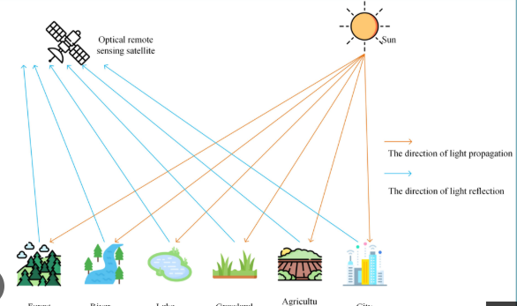
Limitations of Edge Detection:

- Edges are not distinctive enough:
Edge detection identifies boundaries where image intensity changes significantly. However, many different objects can have similar edges, making it difficult to determine whether two edges correspond to the same geographical feature.
- Sensitivity to illumination:
Satellite images captured at different times may have different brightness and contrast due to changes in sunlight, weather, or atmospheric conditions. These changes can alter the detected edges and reduce matching accuracy.
- Effect of image orientation:
If the satellite images have different orientations, the position and direction of edges may change. This can make direct edge-based matching unreliable.
- Background details cause false matches:
Unimportant background structures may also produce strong edges. The system may incorrectly consider these edges as matching features.
- Poor feature localization:
An edge represents a continuous boundary rather than a specific point. Therefore, selecting a unique and stable point on an edge for image registration is difficult.

Harris Corner Detection
Harris Corner Detection identifies corners, which are points where the image intensity changes significantly in more than one direction. These points are more distinctive than ordinary edges and can be used as stable feature points for matching.

The basic process is:
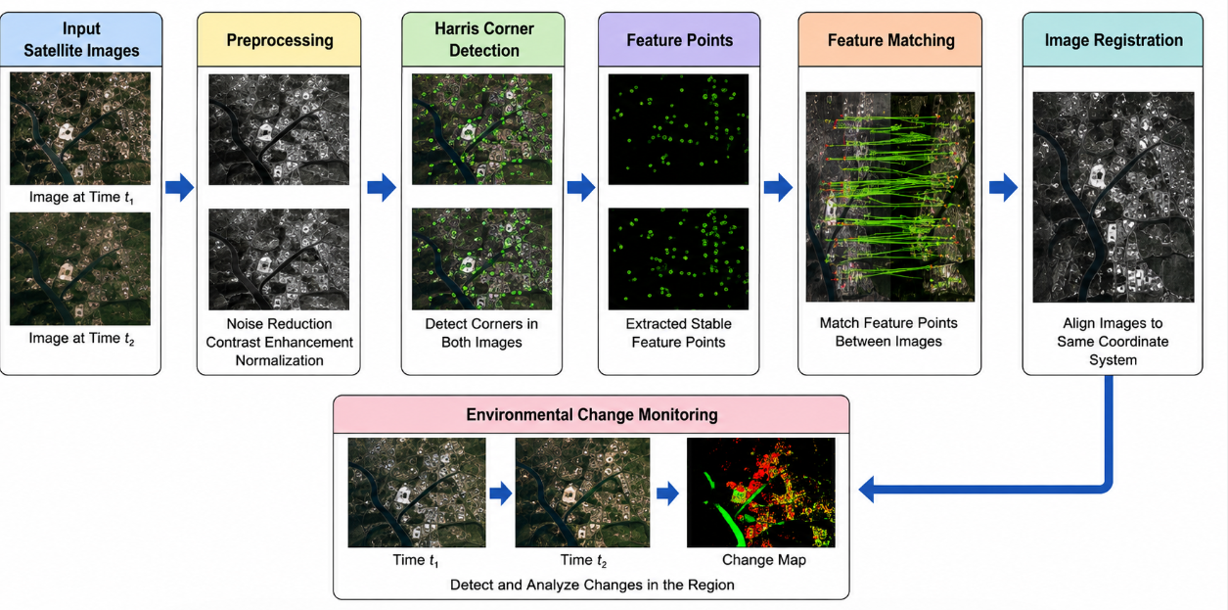

How Harris Improves Feature Localization:
Harris detects locations where intensity changes strongly in both the horizontal and vertical directions. Such locations usually correspond to corners or junctions. Because these points are spatially well localized, they provide better reference points for aligning two satellite images.
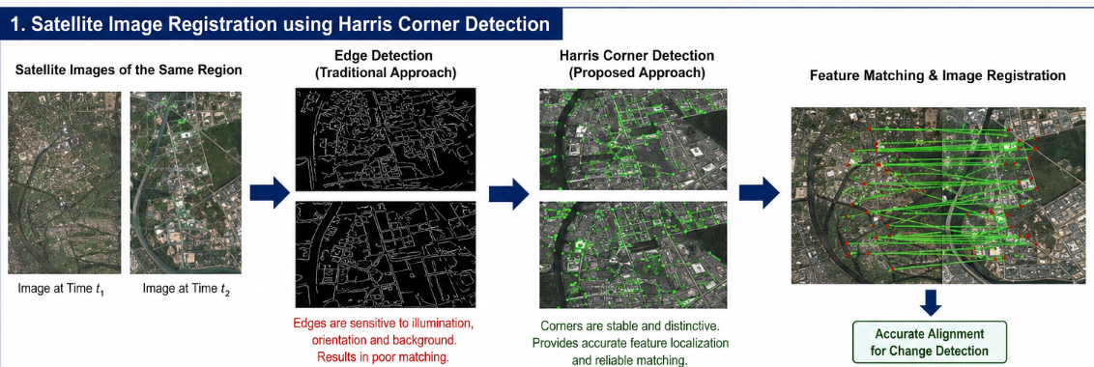

Improvement in Matching Accuracy:
Harris corner points are more distinctive than general edges. When corresponding satellite images contain the same geographical structures, such as boundaries, intersections, or distinct regions, their corner features can be matched more reliably.
This reduces incorrect matches that may occur when only edges are considered.

Improvement in Robustness:
Harris Corner Detection provides more stable feature points under varying imaging conditions. Although illumination and orientation differences can still affect the results, using distinctive corner features provides a more reliable basis for registration than relying only on edges.

Comparison:

Feature | Edge Detection | Harris Corner Detection
Feature type | Edges/boundaries | Corners/interest points
Localization | Less precise | More precise
Distinctiveness | Relatively low | Higher
Matching accuracy | Lower in complex scenes | Better
Effect of background | Can cause false matches | More distinctive points
Image registration | Less reliable | More reliable
Suitability for this case | Limited | More appropriate

Conclusion:
Edge detection is useful for identifying boundaries, but it is not sufficient for reliable satellite image registration because edges can be ambiguous and are affected by illumination, orientation, and background details. Harris Corner Detection provides stable and distinctive feature points, improving feature localization and matching accuracy. Therefore, replacing the edge-based approach with Harris Corner Detection is a suitable solution for achieving more reliable image registration and environmental change monitoring.

2.An autonomous surveillance system continuously captures high-resolution color images to detect vehicles and pedestrians in real time. Processing the original color images directly increases computational complexity and slows down feature extraction, making it difficult to achieve the required processing speed. To improve system performance, the engineers consider converting the images into grayscale or binary representations before applying feature detection algorithms. Analyse the impact of different image representations on computational efficiency, edge detection, and feature extraction performance, and justify the most appropriate image representation for achieving accurate and reliable object detection in real-time computer vision applications.

Introduction
The given autonomous surveillance system continuously captures high-resolution color images for detecting vehicles and pedestrians in real time. Processing full-color images increases computational complexity and slows down feature extraction. Therefore, grayscale and binary image representations are considered to improve processing speed.

1. Color Image Representation:
A color image generally contains multiple channels, such as red, green, and blue. Processing all channels requires more data and computational operations.
Advantages:
- Preserves complete color information.
- Useful when object detection depends strongly on color.
- Provides more information for complex image analysis.
Limitations:
- Higher computational complexity.
- Requires more memory and processing time.
- Can slow down feature extraction in real-time systems.

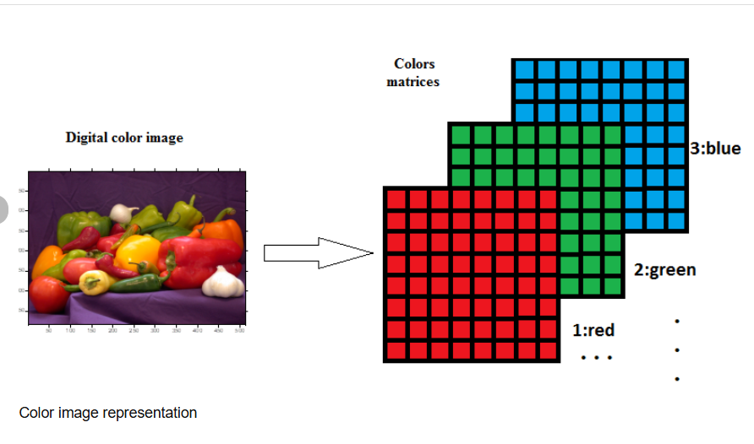

2. Grayscale Image Representation:
A grayscale image represents intensity using a single channel instead of multiple color channels. Converting the original color image to grayscale significantly reduces the amount of data that needs to be processed.
Advantages:
- Lower computational complexity.
- Requires less memory than color representation.
- Makes edge detection simpler and faster.
- Preserves important intensity and structural information.
- Suitable for feature detection algorithms.
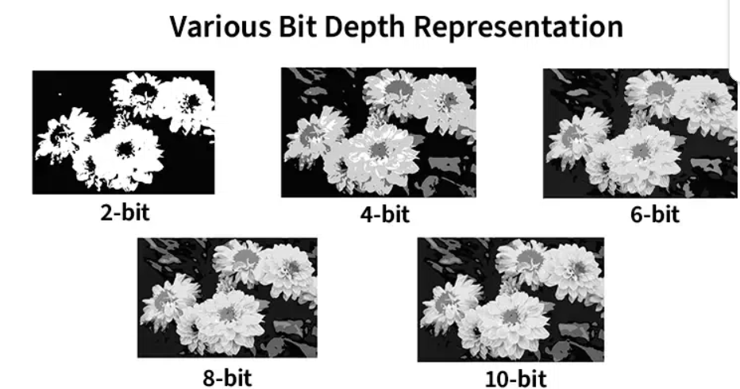
Effect on Edge Detection:
Grayscale images are highly suitable for edge detection because edges are primarily identified from changes in intensity. Removing color information simplifies the edge detection process while retaining important structural boundaries.
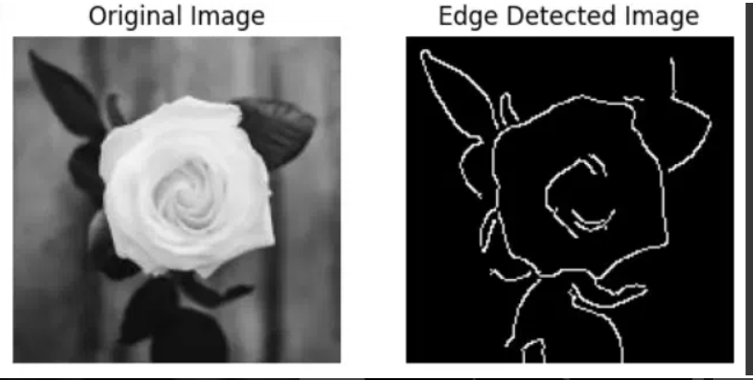

Effect on Feature Extraction:
Many feature extraction techniques can operate effectively on grayscale images. Since only one intensity channel is processed, feature extraction can be performed faster.
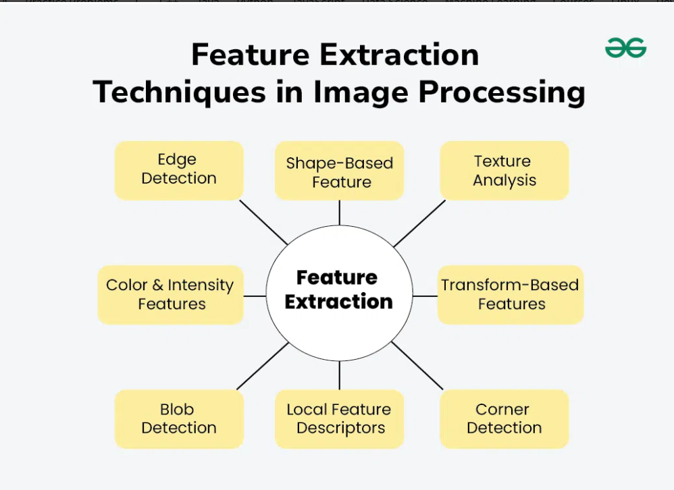

3. Binary Image Representation:
A binary image contains only two intensity values, normally representing foreground and background.
Advantages:
- Very low computational complexity.
- Requires less memory.
- Fast processing.
- Useful when objects can be clearly separated from the background.
Limitations:
- Loses a large amount of image information.
- Sensitive to threshold selection.
- Fine object details may disappear.
- Can negatively affect feature extraction when objects have complex shapes or varying intensities.
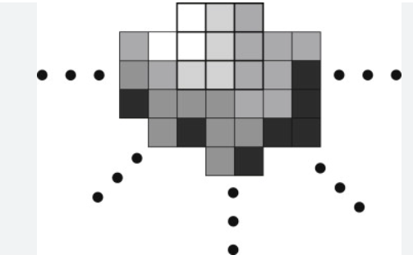

Comparison:

Representation | Computational Efficiency | Edge Detection | Feature Extraction | Information Preserved | Suitability
Color | Low | More complex | More computationally expensive | High | Limited for real-time processing
Grayscale | High | Effective | Effective and faster | Moderate | Best overall choice
Binary | Very high | Fast for clear boundaries | Can lose important details | Low | Suitable for simple segmentation

Recommended Processing Pipeline:

High-Resolution Color Image → Grayscale Conversion → Preprocessing → Edge Detection → Feature Extraction → Object Detection.

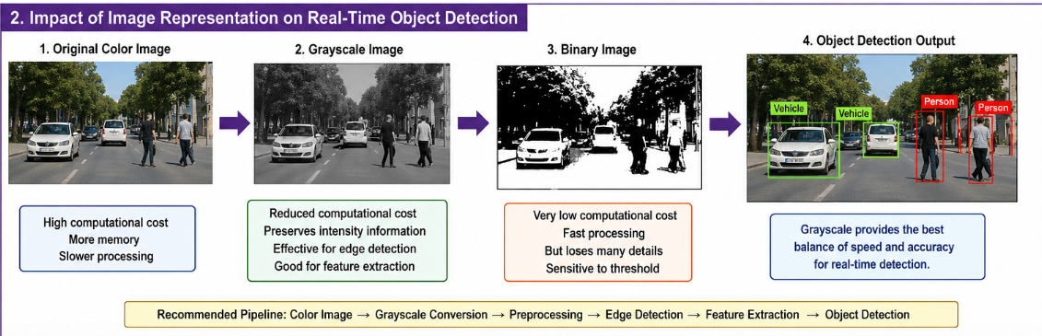
This approach reduces computational complexity while maintaining sufficient information for accurate and reliable object detection.

Conclusion:
Color images contain more information but require greater computational resources, making them less suitable when real-time processing speed is important. Binary images provide very fast processing but lose significant image information. Grayscale images provide the best balance between computational efficiency, edge detection, and feature extraction. Therefore, grayscale representation should be selected for the given autonomous surveillance system to achieve accurate, reliable, and faster real-time object detection.

